Jack Barker earns Pioneer Award in Middletown
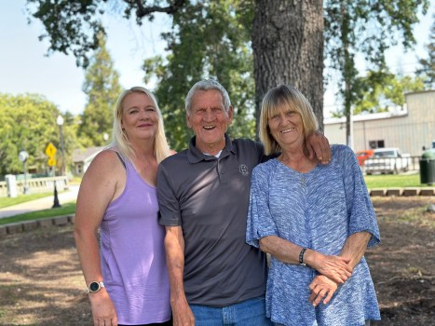
The Barker Family, from left: Diana Stanley, Jack Barker and Shirley Barker.(courtesy photo)
By NIKKI CARBONI
PUBLISHED: June 13, 2023 at 6:47 a.m. | UPDATED: June 13, 2023 at 1:24 p.m.
MIDDLETOWN— This year’s Pioneer Award at the Middletown Days Parade goes out to Jack Barker, lifelong resident of Middletown and devoted community volunteer. Known as the “Mayor of Middletown” Barker has been deeply involved in all of the town’s events from filling in for Santa Claus to helping extinguish wildfires – when it comes to volunteering, Barker truly is a Jack of all trades.
The award comes shortly after Barker celebrated his 80th birthday as he was born on May 8 1943. Despite his age, Barker finds joy in volunteering as often as possible. “I just like to get out and do things,” he said. There is no task too large for Barker as he has volunteered in almost every aspect of local life. He helps out at the local schools ,specifically on the field during football, baseball, softball and basketball games. He plays mascots like Smokey the Bear and Sparky the dog at events and parades, he helps out local businesses like Hardester’s, and was also first on the scene when Hardester’s caught fire in 2018.
Barker shared, “I just got home and was taking my shoes off when I heard it on the scanner. I put my shoes right back on and ran down there, got a big hose and started spraying.” Barker also described his experience during the Valley Fire in 2015. “When they had the big Valley fire I was working with the Red Cross.” Not only was he helping put out the fire, but Barker was also asked to ride along with law enforcement to ensure everyone had evacuated noting because of his familiarity with the area. Barker has been volunteering with the local fire department since he was 16 years old attending Middletown High School.
Reminiscing on his youth and days at Middletown High School in the late 1950s Barker explained that he was one of eight students in his graduating class. He also shared nostalgic memories of working in his father’s auto repair shop and doing cannonballs in the local pool next to the high school with his 12 siblings, four of which remain. He is the eldest of the siblings. Currently Barker resides in the same house he grew up in with his sister Shirley while his niece Diana Stanley cares for them both. Stanley is a local bus driver who described her uncle as being “a staple of town” as he continues to be present through his own struggles including knee and heart surgeries.
“Middletown is his whole life” shared Stanely as she described the depth of his volunteering. “The kids are his motivation” she said while discussing all of the different characters Barker has played with Barker adding “It was hot when I did Smokey but there was a fan in the top that would keep you cool.” Barker recounted these occasions in costume as if they happened yesterday.
Jack Barker will be featured on a float during this year’s Middletown Day Parade this Saturday at 10 a.m. The Middletown Days has been a long standing tradition in Middletown and begins Friday June 16 with a rodeo, continuing on Saturday and Sunday with the parade, contests, tournaments, vendors and dances. More information is available at middletowndays.org.
Top Stories01:00Grammys 2024: See the list oftop winners

Surge in syphilis cases leads some providers to ration PenicillinWhen Stephen Miller left his primary care practice to work in public health a little under two years ago, he said, he was shocked by how many cases of syphilis the clinic was treating.
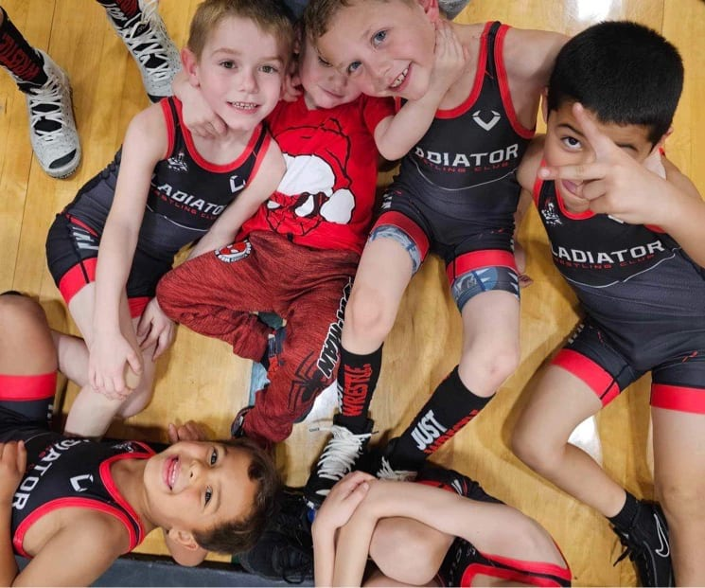Gladiators take home 3rd at Bob Colvig InvitationalForty three Gladiators laced up their shoes and went off to battle at the 4th Annual Bob Colvig Invitational and came home with a 3rd place finish at Willits High School on Sunday, January 21.
California ends COVID isolation rule for asymptomatic cases as winter infections climbCalifornians infected with COVID-19 may go about their lives without isolating or testing negative as long as their symptoms are improving, according to new and significantly loosened guidelines from the California Department of Public Health.
Native American communities have the highest suicide rates, yet interventions are scarceAmanda MorningStar has watched her children struggle with mental health issues, including suicidal thoughts. She often wonders why.

Dr. Kellyann: "Weight Loss After 60 Comes Down To This Daily Habit""My friends are convinced I got a tummy tuck, but I just drink this daily."Dr. Kellyann|
Sponsored
Learn More

Animal Activist: Add This To Your Dog's Kibble (Here Is Why)Katherine Heigl has spent years researching how to help her dogs live a longer, healthier life. Here is one of her best discoveries!Badlands Ranch|
Sponsored
Learn More

3 Toxic Foods For Dogs: The One Meat You Should Never Feed Your DogDo you know what foods are dangerous for your dog?Dr. Marty|
Sponsored
Learn More

Three San Francisco Banks Paying Record High Interest - See the ListSuggest-me|
Sponsored

This Drugstore Wrinkle Cream Sold Out At Target (In 2 Days)Super C Serum|
Sponsored
Learn More

Cardiologists: Overweight? Do This Before BedHealthy Guru|
Sponsored
Learn More

Here is the real cost of full mouth dental implants in 2023Suggest-me|
Sponsored

Kaley Cuoco Flaunts Fierce New Figure In Latest PhotosCelebrity HQ|
Sponsored

Cardiologists: Unwanted Pounds? Do This Before BedHealthy Guru|
Sponsored
Learn More

Everybody Wanted To Date Her In The 80's & This Is Her RecentlySweet Penny Stocks|
Sponsored

Top Doctor: If You Eat Oatmeal Every Day, This Is What HappensTop US Doctor: Sugar Is Not The Problem (This Is)GundryMD|
Sponsored
Learn more

Diabetes Is Not From Sweets! Meet The Number One EnemyTop Surgeon: Anyone With Blood Sugar Over 100 Should Try ThisWellnessGuide|
Sponsored
Learn more

Seniors Under 85 Years Old Get $250k In Life Insurance for $13/MonthBest Life Insurance OptionsBranded Links|
Sponsored
Learn more

Most Popular
MOST POPULAR
- Grammys 2024: See the list of top winners
Grammys 2024: See the list of top winners
- In Our Opinion: Our March 5 primary election endorsements
In Our Opinion: Our March 5 primary election endorsements
- 4 great low-alcohol drinks for taking it easy
4 great low-alcohol drinks for taking it easy
- California’s unjust civil justice system still a ‘Judicial Hellhole’
California’s unjust civil justice system still a ‘Judicial Hellhole’
- 2024 will test us. What can we learn from Strength, tarot’s card of the year?
2024 will test us. What can we learn from Strength, tarot’s card of the year?
- Mary Lou Retton tries to explain why she couldn’t afford health insurance
Mary Lou Retton tries to explain why she couldn’t afford health insurance
- Surprise revelation in spirited District 1 debate
Surprise revelation in spirited District 1 debate
- News Briefs
News Briefs

TRENDING NATIONALLY
- Grammys 2024: Taylor Swift announces new album ‘The Tortured Poets Department’
- For Navy submarines and Norfolk’s USS Pasadena, surfacing for supplies is a matter of life or death
- Delta pilot sues after Denver airport moving walkway “swallows” his foot
- Wildlife officials aim to keep Colorado’s wolves from meeting the endangered Mexican wolf. Is separation the right goal?
- Trump jumps ahead of Biden in new NBC poll, reveals VP shortlist

MORE IN NEWS

Biden sails to victory in South Carolina’s first in the nation Democratic presidential primary

Creditor claims against a decedent’s trust estate.

News Briefs

Kitchen Madness!
- 2023
- June
- 13
- SUBSCRIBE
  - e-Edition
  - Sign Up For Newsletters
- CONTACT US
  - Lake County Destinations
  - Work With Us
  - Privacy Policy
  - Accessibility
  - Sitemap
- ADVERTISE WITH US
  - Place an Ad
  - MediaNews Group Advertising
  - Today’s Ads
- CLASSIFIEDS
  - Local Guide
  - Jobs
  - Real Estate

SUBSCRIBE NOW
- Terms of Use
- Cookie Policy
- California Notice at Collection
- Notice of Financial Incentive
- Do Not Sell/Share My Personal Information
- Arbitration
- Powered by WordPress.com VIP
Copyright © 2024 MediaNews Group

