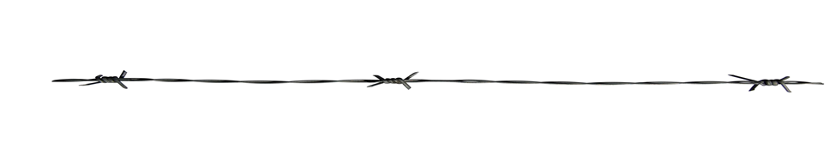
Team Roping Buckle $200______ ½ Buckle $100______

Junior Rodeo Buckle $125 ______
Event Sponsorship $150 ______
Dummy Roping Buckle $125 ______ Dummy Roping Awards $150 ______ (1st 20 kids)
Buckin’ Ball Buckle $125 ______ Buckin’ Ball Buckle Awards $150 _____ (1st 20 kids)
Flags are paraded during parade & rodeo events.
Mutton Bustin’ Buckle $125 ______ Mutton Bustin’ Awards $150______ (1st 20 kids)
Flag with your business name $350 ______ (includes set up fee-first year)
Each year after $200 ______

Chute Sponsor $300 ______
Gymkhana Buckle $200 ______ ½ Buckle $100______
2nd , 3rd , 4th and 5th Any ______ (Prizes range from $45-$100)
Hide Race Buckle $200______ Rescue Race Buckle $200______
Parade Trophy $30 ______
Sweepstakes Trophy $250 ______
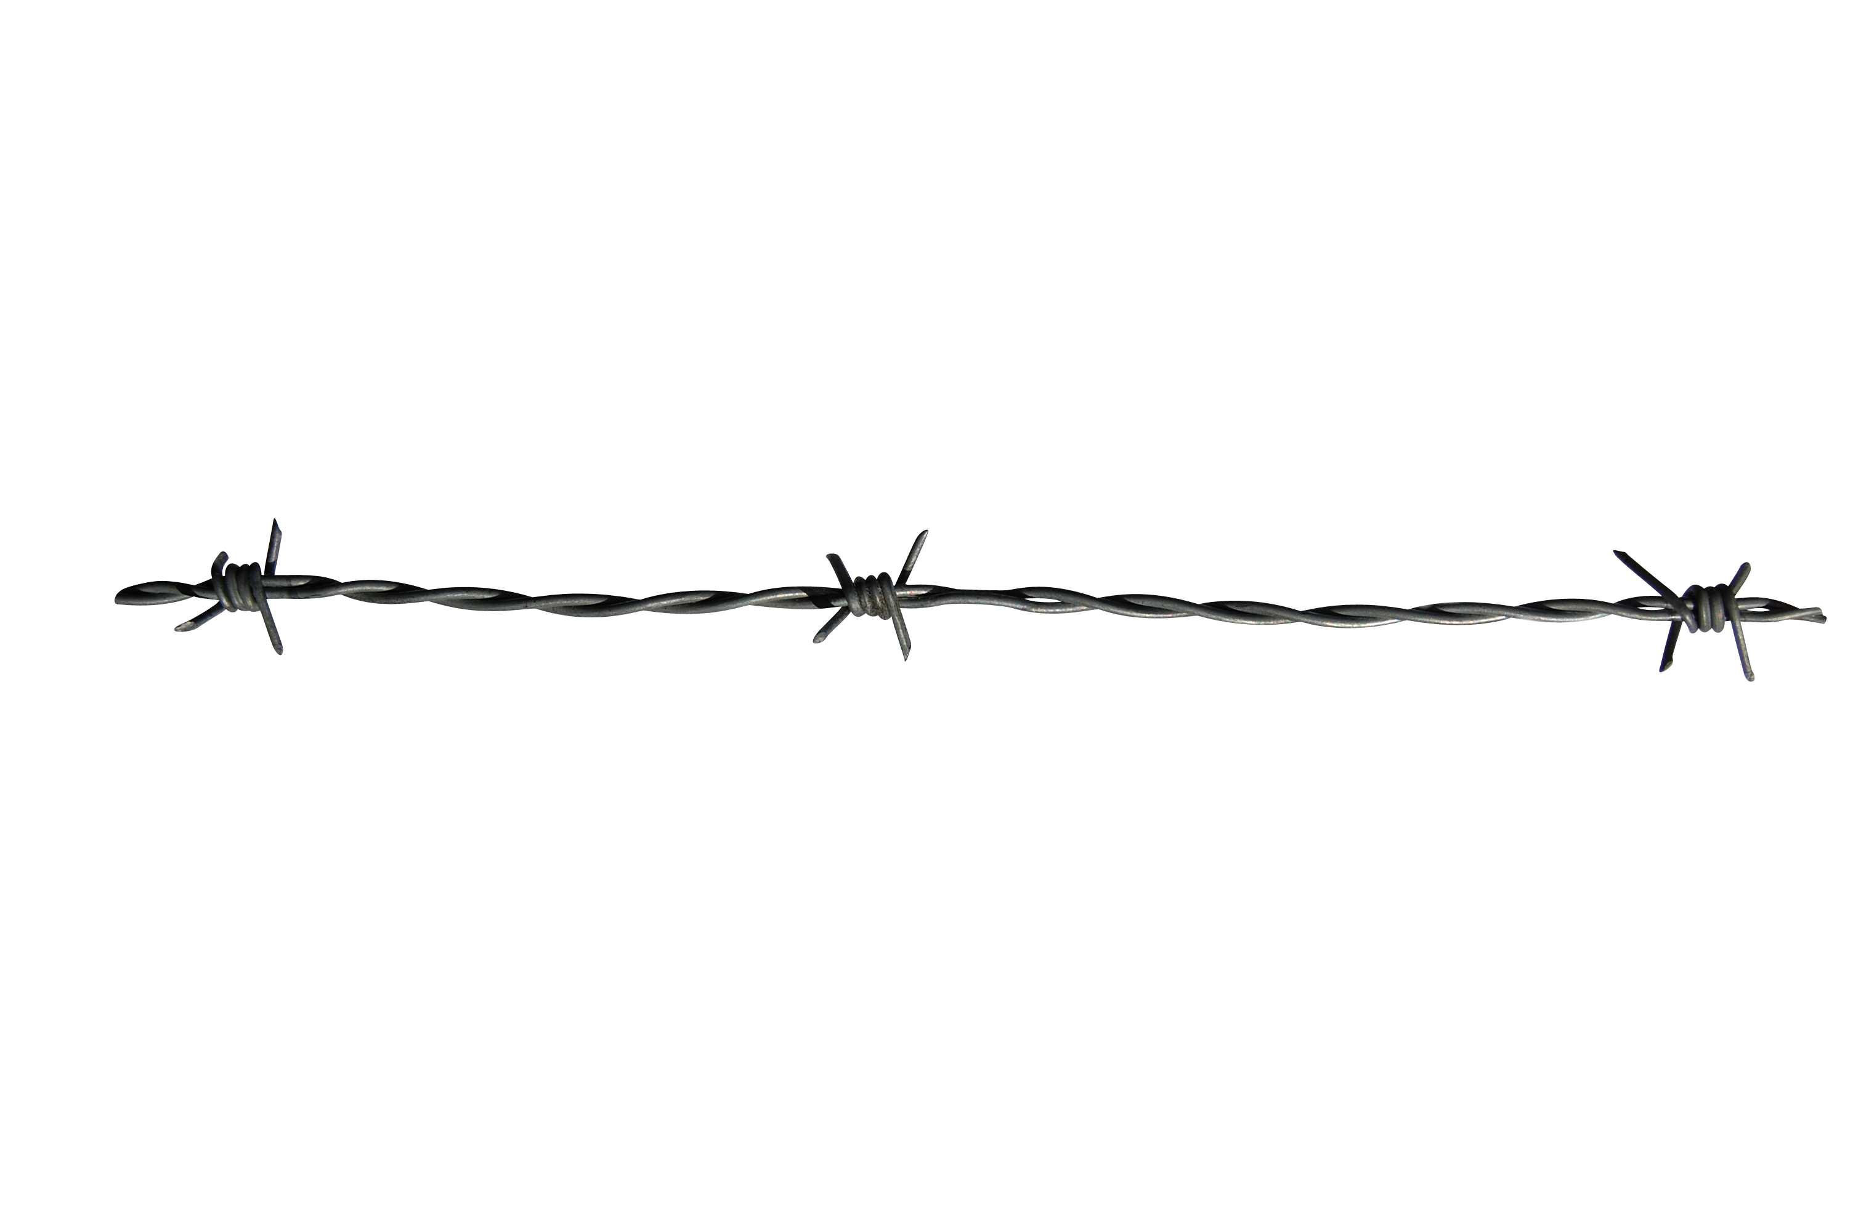
Rod Huston Sit Up Straight Award $50 ______ (Hardester’s Corner Store Gift Certificate)
Lila Lee Simon Award $50 ______

Horseshoe Tournament $ 100 _______
Queen & Princess Contest (buckles & awards) partial $100 _______ full $200 _______
Arena sign $ 50 ______ (yearly fee) $ 175______ (NEW SIGN - 1st year set up fee included)
Playday partial $100 ______ full $500 _______
Friend of the Park Your choice of donation amount $ __________

Please fill out bottom portion so that we may recognize you and/or your business for supporting us!
Name: ______________________________________________________ Phone: ___________________
Address: ____________________________________ City: _____________________ Zip: __________

