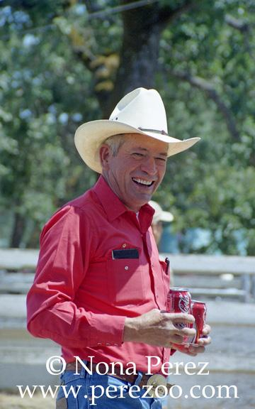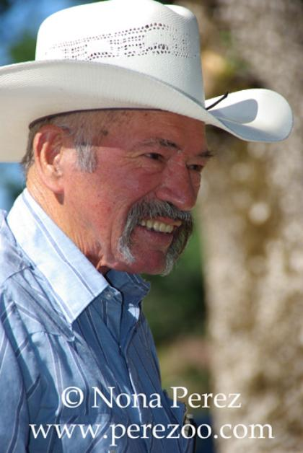
Bob Roberts
This year's Pioneer Award goes to a man who exemplified what life in a small rural community is all about. You need a lot of skills, a resilient and generous spirit, and a willingness to do whatever needs to be done.
This pioneer has been a sailor, a truck driver, a geothermal hand, an artist and a cowboy. He was a familiar face around the Central Park arena, teaching people roping, helping with the cattle, working the chutes, and offering friendly advice. You might know him as Cowboy Bob, but his real name is Robert Roberts.
Now, I know what you're thinkin', because I thought it myself. Did his parents run out of names for the kids? The answer is much more interesting, and it's linked to how he met his wife and ended up settling in Middletown. But more of that later.
Roberts was born in Austin, Texas on Oct. 7, 1941. His grandfather was a Baptist preacher and his dad was a cowboy. His dad moved the whole family-an older sister and three younger brothers-every time he changed jobs, so Roberts grew up all over the area around Austin, San Antonio, and New Braunsfeld.
He joined the Navy and ended up serving a total of 12 years, with a four-year hiatus between hitches. He did two tours in Vietnam as torpedo man, and suffers from hearing loss and ringing in the ears from the 24/7 pounding of the big guns shelling the South Vietnam coast.
He rode out a typhoon that nearly capsized his ship and watched in awe from 5 miles out as the mushroom cloud rose from the underwater nuclear tests near Christmas Island in 1962.
When Roberts was stationed at Mare island in the early '70's he visited his cousin Mary in Middletown. He met Jim Kinyon, a longtime resident whose wife Donna happened to be friends with a cute cowgirl from Pope Valley.
Donna decided Kathy and Bob would be the perfect couple and set about making it happen. Kathy Roberts grew up in the area and graduated from Middletown High in 1964. She was living in Pope Valley at the time and was active in the Pope Valley Ropers and Riders.
At Donna's insistence, Kathy met Bob at the Kinyon house in 1972. It appears Donna was right, because the couple married two months later and will celebrate their 40th anniversary in December.
The Roberts had an instant family, with three kids of Bob's and one of Kathy's. Soon they added a daughter, and all the kids attended Middletown schools until the family moved out of state for few years. They came back in time for all five kids to graduate from Middletown High.
Meanwhile, Roberts had finished his navy service and started his new career as a cowboy.
"I'd always wanted to be a cowboy," Roberts said, and Middletown gave him the chance to try. He went to work at Diamond Ranch where Darrall Mosley first taught him how to rope. Rudy Yudnich and Jim Kinyon helped him hone his skills, and soon Roberts was a roping phenomenon, able to rope either the head or the heel with either the head or the heel with equal aplomb.
He was only at Diamond D for a couple of years before moving away, and when he came back in 1984 Roberts went to work for Obie's Drill Pipe Service. The geothermal industry was still booming then and there was plenty of work on Obie Sander's famous hard banding machines that welded the drill pipe.
Kathy and the kids were happy too, with finally enough room for the whole brood and their horses and 4-H/FFA projects. In 1988, Roberts went back to the cowboy life, working at Guenoc Ranch for 10 years.
He injured a shoulder at work and they thought he wouldn't be able to rope any more, so worker's comp sent him to truck driving school. He got hit from the rear on the way to his first day of school, but finished the course and drove truck for Pt. Lakeview Redi Mix for awhile.
But Cowboy Bob wasn't quite ready to trade a horse for a truck permanently, he learned to rope with his left hand, just in case. He also worked for a time with the lake County Sheriff's Mounted Posse. Both Bob and Kathy also served as officers for the Pope Valley Ropers and Riders.
The shoulder injury and neck injuries from the accident eventually landed him in the hospital for surgery. His time in a hospital bed got him to return to a talent he had nearly forgotten. As a kid he used to draw cowboy comic strips, but had let his artistic ability lapse.
"I was going stir crazy'" Roberts said of this recovery from neck surgery. He had Kathy bring him paper and pencils and he started to draw. He got some help from his cousin, June Burnett of Middletown, an accomplished artist in her own right and a severe critic of cousin Bob.
Cowboy Bob's pencil drawings of local barns now grace many a Middletown home to remind us of our roots and the timeless beauty of old wood. They preserve a time when the barn was as much the center of life as the house and the barn construction tells a story of its own.
Roberts also had a scary bout with throat cancer, but he's back to work now at Diamond D Ranch. At the age of 71 he's still roping and teaching Diamond D owner Mike Browning and his kids how to rope.
Roberts has always enjoyed sharing his skill, and that's one of the reasons he's this year's Pioneer. He has taught some roping clinics at the Central Park arena, provided building supplies for park projects and has ridden in the parade with the Pope Valley Ropers and Riders. He's always been willing to help whenever needed.
Only one of the Roberts kids, Carolyn still lives in Lake County. She's a former Middletown Days queen. Sister Angela was a parade princess and now has four kids and lives in Cedarville. Son Jason is a major in the Army, currently serving in Afghanistan and contemplating retirement. Sons Corey and Lonnie both live in Washington state. The Roberts have 13 grandchildren, and one Angie's son John Hackler III, is a working cowboy like his grandfather.
If you've read this far you probably want to know about that name. His dad's sister Aunt Tennie, and her husband had made their way from Texas to Lower Lake with daughters Mary and June who figured so prominently in Bob's wedding and artistic career.
But Tennie was still living in Texas when her sister-in-law was pregnant with child No. 2 Ola Roberts was so grateful for the help that she asked Tennie to name the child, and Tennie wanted him named for her husband, Robert..
And so we have Robert Roberts, the Coca Cola Cowboy and a man of many talents, riding at the head of the parade as a man who has preserved the pioneer spirit through his work, his art, and his support of the community.
Article written by Martha Webster, Middletown Times Star

