Calpine: Community Partner and Middletown Days

2016 Grand Marshal
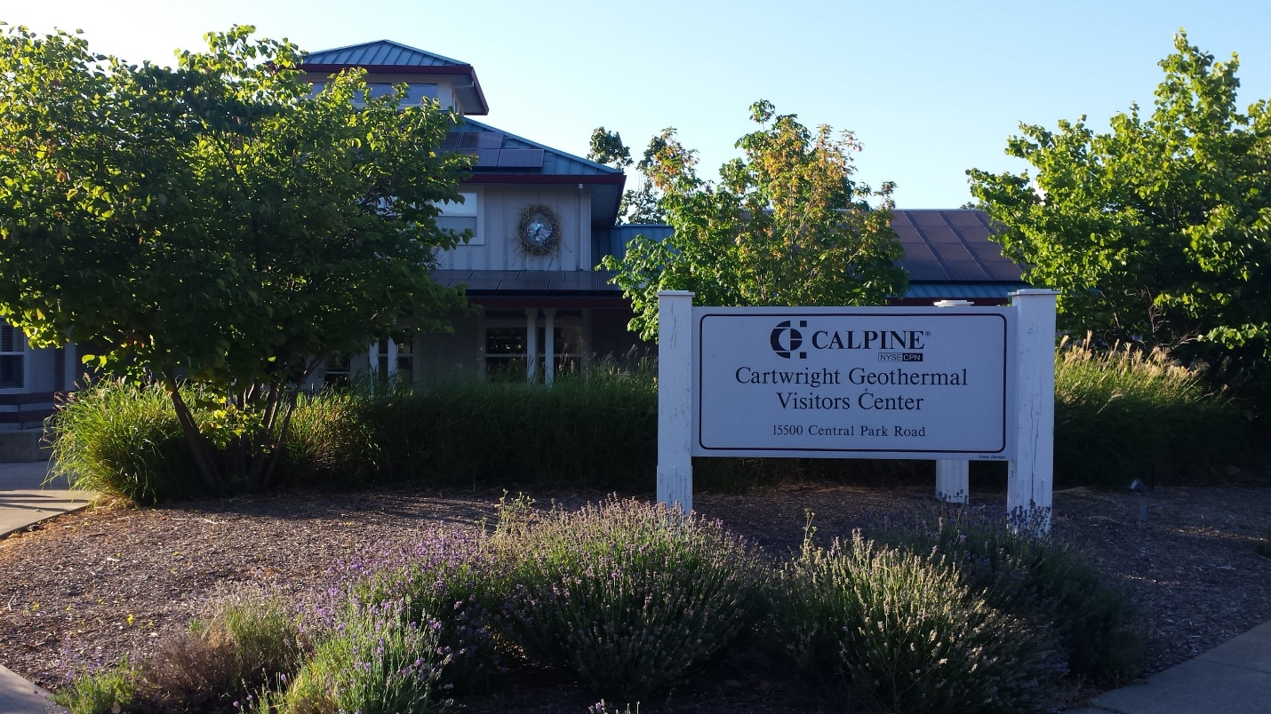
The Geysers began producing electricity in 1922 in an attempt to power The Geysers Resort. In 1954, the first modern well was drilled which lead to PG&E building and operating Unit 1 in 1960. It was the first modern geothermal power plant in the United States.

By 1987 there were 21 independently owned and operated plants. A rapid decline in power generation began as a result of pressure loss in the steam reservoir.

Calpine’s purchase in 1989 of a 1-megawatt interest in the Aidlin power plant would eventually grow to become the largest complex of geothermal power plants in the word. Calpine would go on to become the largest geothermal power producer in the United States. But, first, they would have to address the decline in power generation at the Geysers.

By 2000 Calpine had purchased 19 of the plants and could adopt a field wide approach to sustainably managing the natural resource. This involved linking streamfields, closing some power plants and linking the remaining power plants.

They also embarked on two revolutionary recycled water projects to stabilize the steam decline. The South East Geysers Effluent Pipeline in 1997 and the Santa Rosa Geysers Recharge project in 2003.

Calpine won the Outstanding Lease and Facility Maintenance Award from the Department of Conservation for operations at the Geysers 11 consecutive times. The award recognizes lease maintenance efforts that enhance safety and environmental protection above and beyond what is required.

But, Calpine isn’t just a good neighbor environmentally, they are also a supportive community partner. Each year, Calpine Geysers pays royalties to area landowners, the State of California (which helps fund the State Teachers Retirement Fund) and Federal agencies. In 2014 alone, Calpine paid over $27 million in royalties. And, they are the largest taxpayer in both Lake and Sonoma counties.

The Geysers also employ over 300 full time employees and relies on 150 independent contractors. Over 70% of this workforce resides in Lake County.

During the Valley Fire, Calpine generously donated to the Red Cross, Lake County Search and Rescue and Redwood Credit Union Valley Fire Relief fund. They purchased and distributed cleaning supplies at the Visitor Center and their employees volunteered around the clock at the Middletown, Kelseyville and Lakeport distribution centers. They also loaned out the Visitor Center parking lot to the Red Cross kitchen for preparing the meals that were distributed in the community.

Calpine coordinated and sponsored the first Valley Fire information meeting and a family movie night in Middletown following the MATH meeting. They partnered with the Moore family to host the Cobb Community get-together, Twin Pine to host a fundraiser golf tournament for MAMA and Lake County Rising, multiple partners for the Cobb Community Halloween Get-Together, and with Black Rock for the free Winter Wonderland winter break event which included an ice ring, zip line and toy give away.

Calpine also supports our area’s local Chamber groups and regularly loans out the use of their visitor’s center to local community groups for meetings, trainings and other events
Their employees fundraise and volunteer on their own time with Relay for Life, the Middletown Senior Center, Sober Grad, Special Olympics, Rotary and Lions Clubs, the Gibson Museum & Cultural Center, Climate Protection Campaign, LandPaths, FFA and 4H.
Danielle Matthews Seperas, Calpine Manager over Government and Community Affairs, ”For me, Middletown is my home town and I am so proud to be part of this year’s Middletown Days festivities and on behalf of Calpine Corporation, we very much appreciate being selected as this year’s Grand Marshal – it is truly an honor!”

