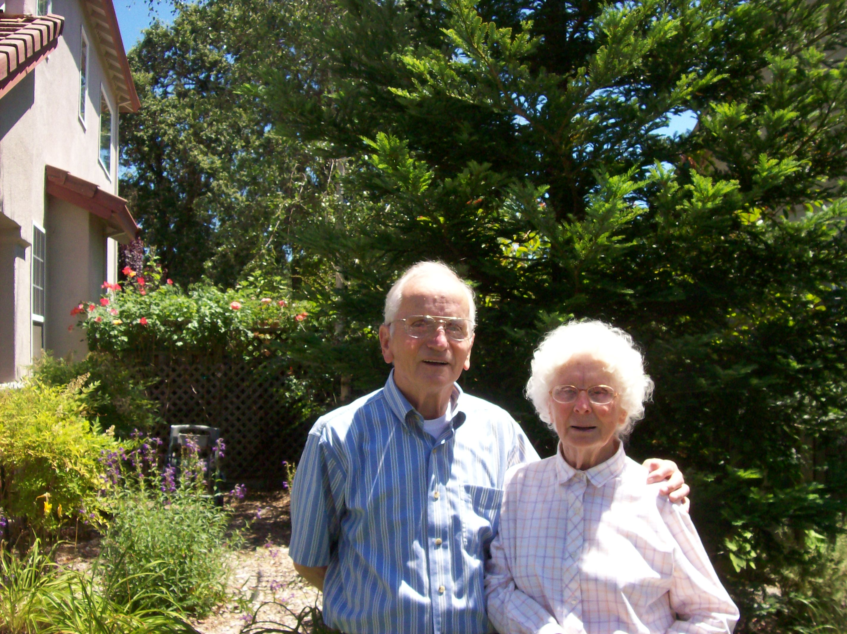
Pioneer Award Recipient Ellen & her brother Fred Roads

This years Pioneer award recipient is long time resident, Ellen Hunt. She may not be a true “native daughter” of Middletown, but she has deep roots here and has blazed a trail of community service that makes Middletown proud. Ellen was born in 1929 in Calistoga’s old hospital, to Bessie and Joe Roads; natives of Lompoc and Philo, California. Two more children, Bernice and George, were born in Calistoga where Joe installed electrical lines over Mt St Helena, as well as doing road work on old Hwy 175 up Cobb.
The great Depression put an end to this contracting business. The family moved to Pope Valley, where two more children-Fred and Henry-were born. There Joe worked as a woodcutter, dragging trees off the hill by mule, until a tree whipped around and crushed his pelvis. With his ability to work severely limited, the family resorted to following the seasonal work. Often times they lived in tents on ranches in the Napa Valley where they picked the crops-grapes, prunes, pears, etc. The kids learned what hard work was, but still managed to attend school in Pope Valley until the family moved and settled in Napa.
Around 1937 they came to Middletown to collect scrap iron to sell to the Japanese. Bessie was pregnant with her sixth child when she was injured while helping another worker. The Roads’ stayed with the Parriott family here until the baby, June was born. Ellen and her siblings played in Cache Creek near where she now lives on Big Canyon Rd and remains friends the Parriott family.
The Roads’ returned to Napa, where two more children-Barbara and Ruth were born. Ellen recalls that sometimes on Chiles Valley Road, they’d give a ride to a young man who lived with his grandparents and pedaled his bike all the way to St Helena for school. After which, he would shine shoes to earn spending money. Ellen didn’t think much of it, at the time. But when Al returned from Army service, he came to the Road’s home to help her Dad work on his Model A.
Al Hunt, was a strapping, handsome young man and a hard worker. They married in 1947 and Ellen set about beating her mother’s record for hard work and children. Ellen worked alongside her husband for fifty four years and raised nine kids. Day to day work included managing fruit orchards, woodcutting and sales; just about anything that would put beans and bread on the table. In 1966, the couple bought a loader and dump truck and went into the gravel hauling business. By that time, they had nine children-Shirley, Beverly, Ellen, Alfred Jr, John, Elizabeth, Faith, Jeffry and Allison.
In 1937, Al and Ellen came to visit the Parriotts’ and Ellen just knew she’d like to live in Middletown, now that the kids were grown. They found a cabin on Santa Clara, but kept their eyes open for property with river access. One day, while on a ladder, putting insulation in the roof, a friend dropped by to tell them of a former gravel plant for sale on Big Canyon Road. Ideal; they bought it, started running the gravel beds, installed a modular home, and built a huge barn/shop to accommodate equipment repairs and Al’s hobby-antique tractors and engines.
In 1977, son Jeff came to Middletown to raise his family and become partners with his dad. In 1993, with business slow and his hearing failing, Al retired and Jeff continued a backhoe business alone. Ellen continued to keep up the bookkeeping side of things. Al turned his energy to scouring swap meets and repairing old equipment to sell or trade.
Over the years, Ellen and Al also raised mules. They were active members of “Early Day Gas Engine & Tractor #31”. Every summer there was always something to interest the grand kids. Besides their nine children, there are now twenty grandchildren, twenty-five great-grandchildren, and two great-great-grandchildren. It naturally followed that they often participated in the local parade. Whether they rode mules, horses or antiques tractors, it was always a special day for a family gathering.
On the note of grandchildren, in 1994, when their son Jeffry passed away, Ellen stepped up to help Susan raise the three Hunt boys. Little did she know that the school athletic department would become accustomed to seeing “Grandma” in the bleachers. First, Jason re-acquainted her with the game of football. Then Brian introduced her to wrestling, and continues to do so through his coaching. Lastly, Tyler made her proud with his basketball prowess. Not only did she receive an education in sports, she was blessed with the small town camaraderie; in the process, forging many new and lasting friendships.
In 2001, when Al passed away Ellen began a new chapter in her life. Thanks to her “special angel” the late Martha Webster, Ellen’s picture and story was often “front and center” in the Middletown Times Star, reporting her selfless work for the flying Doctors. What started out as a day helping her brother, Fred Roads, load a truck with medical supplies, turned out to be much more! Over the next several years, Ellen traveled miles throughout the whole of Lake County and occasionally into Napa, Sonoma, and Mendocino, on her quest to gather donations for the extremely needy medical clinics in Mexico.
The countless hours of work and devotion from Martha are what made it possible for Ellen and Fred to send thirty 53’ truckload; nine of which were amassed and loaded right here in Middletown! Ellen says the “icing on the cake” was the ambulance they were able to send that was obtained from the South Lake County Fire Protection District. None of this charitable undertaking would have been possible without the tremendous community who generously gave themselves with time, labor, money and love. Ellen will be forever grateful.
Yes, she has put away her “flying Doctor” hat and she doesn’t hang out at the gym much anymore. That doesn’t mean she’s sitting still. Her sense of patriotism is and always has been very strong. Now, through Ginny Craven (Operation Tango Mike), she’s found ways to support our men and women in the armed forces. She constantly encourages family and friends to donate in any way they can; because each and every effort is deeply appreciated.
Ellen is extremely proud to be honored as “Pioneer of the year”. Through the years her life has been touched by so many people. These people are what make Middletown such a wonderful community. She’s happy to call it home.

