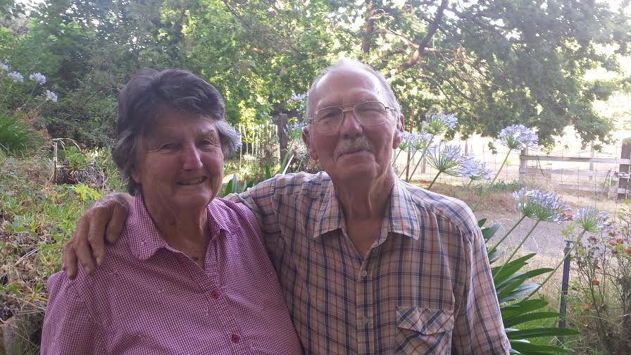
Pioneer Award Recipients Have Long History With Middletown

Most of us don't recall a time when there were no gymkhanas here in Middletown or in Pope Valley. Nor do we recall a time when the traffic was blocked off on Armstrong Street for the Middletown Days Dance. But, this year's recipients of the Middletown Days Pioneer Award, Phil Bickford, 87, and Betty Bickford, 81, do.

Betty and Phil are the only active charter members left of the Pope Valley Ropers & Riders.

Betty wasn't always a roper, but she did practically grow up on a horse in South Dakota. She told me that her mother would ride with her in front and her brother in back. They were 1 and 3 at the time. By the time she was old enough for school she was riding her own horse the three miles back and forth.

Phil, on the other hand, did not enjoy riding much. His early riding experience consisted of hunting on a rented horse that he had to "kick the whole way out and who ran the whole way back."

The two met when Betty was just 14. Her best friend was friends with Phil's brother and the family was going to catch abalone. The girls invited themselves along and the rest is history.

Phil had an apprenticeship on Mare Island. After that he went to college and the two planned to get married after his graduation. While still in school Phil got his draft notice, and though exempt, he knew in June (after graduation) he'd have to go. So, they moved up the wedding plans and got married in December of 1950. Phil elected the Navy over the Army and as luck would have it started boot camp the same week the Japanese surrendered. But, by then, it was too late. He served 11 months. When he got out he headed to Napa College to study automotive mechanics.

That would prove to be fortuitous choice of study for Phil as he was again taped for active duty and sent to Vietnam. Had he only served one more month during World War II he would not have had to go. But, after spending a week in Vietnam he was sent to Thailand due to a need for a heavy equipment mechanic with his training.

Phil would eventually retire after 30 years in the reserves. But, in 1957 the family of 5 were living in a two bedroom house in Napa. And, they were in need of more space. They found a deal on some property they couldn't pass up and after the reputation of the Pope Valley school district, a one room school house, checked out, the family made their move.

Back then the Bickfords, Jim Smith, Forrest Marshall and 5 or 6 other friends used to meet up at their pal Al Mooney's house every Sunday to rope. This went on for quite some time until the group got so big Al worried about liability and the need for insurance.

In December 1961 that group, which by now included Rudy Yudnich and Jim Kenyon, started the Pope Valley Ropers & Riders and had their first official meeting. Everyone in the valley showed up. Anyone that joined by February of 1962 were made charter members. Today, the Pope Valley Ropers & Riders are still going strong, but the Bickfords are the only active charter members left.

The Bickfords disagree on the exact year that the group started riding in the Middletown Days Parade, either 1962 or 1963, but they both agree that the first gymkhana was held West of the current arena in a plowed field. They used bales of hay and lumber to mark the area. "Rudy kept going on about wanting a gymkhana. I said, 'What the heck is a gymkhana?'"

They along with Clarence Wicker helped organize the events and rode in the parade, even serving as color guard.

One of the events the group brought over from Pope Valley was the Hide Ride. Betty remembered how Rudy asked her to pull him with her Buckskin, Buck. "Now, Buck, really loved gymkhanas. We started to go and she stopped and made this noise 'unhn.' Then she dug in and pulled . The next time we pulled Rudy, I put him up a bit so it was easier on Buck. I believe I even pulled Andy Snell. I always pulled. I never rode the hide."

The whole family participated in the parade and competed in the gymkhanas for years until the kids out grew their ponies. Even their niece Jan Hinkey remembers coming up for sleep-overs at their ranch and going to the parade the next day.

The Bickfords confess they continued to compete in the gymkhana until it got too big for them. "Eventually, it just made for a long day."

They continue to be active with their group in Pope Valley and Betty even judges the gymkhana events.

This year they are followed by, and the color guard is comprised of, current members of the Pope Valley Ropers & Riders club.

