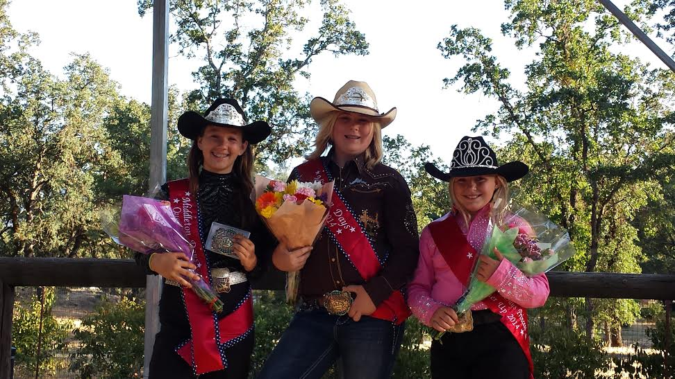

Your Middletown Days 2014 Royal Court

This year the number of contestants for the Middletown Days Queen and Princess was one of the lowest in the history of the competition. But, that didn't make it any easier on the girls or any less exciting. The girls put everything they had into it and the scores were "tight." This year the scores for Princess were within 1/2 a point of each other.

The competition was organized and the girls were coached by Krissy Tighe and other local experts. The girls have been attending weekly clinics since April to prepare for the competition that was held last Saturday. The judge, Michele Ulrech, is a professional horsewoman who works closely with the Livermore Rodeo Queen Contest.

This year there were 10 categories to the competition that were divided into a horse portion that shows off horsemanship and riding skills and an evening portion including modeling, speech, interview and a written test. In addition, the queen candidates have to sell $900 in beef raffle tickets and the princesses $600. All funds go to improve and maintain Middletown's Central Park.

The Middletown Day's Queen contest first started in 1961. In 1968 the Princess contest was added. You can view the list of Middletown Days Royalty by year at http://www.middletowndays.org/royal-court.php Some of the names just might surprise you.

This year, Alisha Mackey's name will be added to that list as Middletown Days Queen for 2014. She is 13 years old and is going into the 9th grade. She has been riding her whole life and competed on her bay quarter horse gelding named Chicken.

Bailey Deberry, is this year's Princess. She is 12, going into the 8th grade, and has also been riding her whole life. She competed on Rebel, her palomino quarter horse gelding. "She's really come a long way," says Tighe.

Lily Emerson, 10 years old and going into the 6th grade, is also part of the Royal Court. She comes from a long line of horsemen and has been riding since before she could walk. She competed on Tyson, her brown quarter horse gelding.

Beef raffle tickets are still available and are only a $1 each. They include a $2 off coupon for a large pizza at the Mount St. Helena brewery and you do not have to be present to win. This year there is 900 lbs of cut and wrapped beef to award. That's double the amount from last year. 1st place will get half, 2nd place the front quarter and 3rd will get the hind quarter. Thank you to the Top Line Cattle company for donating the beef.

The girls will lead off the parade 10 am in Downtown Middletown on Saturday June 21st and they will be on hand all weekend for the rest of the festivities at Middletown's Central Park. See website for a complete list of events.

